PS-Style GAN based Sketch Generator for Facial Entertainment
Mr Ajay Kumar Reddy K  Department of Computer Science and Engineering  SRM Institute of Science and Technology, Ramapuram  Chennai, India  ajaykumarreddykrishnareddygari@gmail.com | Mr Sameer Raja E  Department of Computer Science and Engineering  SRM Institute of Science and Technology, Ramapuram  Chennai, India  efssameer777@gmail.com
Ms Jesheba Fedorah E  Department of Computer Science and Engineering  SRM Institute of Science and Technology,Ramapu  Chennai, India  jesheba.fedorah@gmail.com  Mrs S Kamaleswari  Department of Computer Science and Engineering  SRM Institute of Science and Technology, Ramapuram  Chennai, India  kamaless@srmist.edu.in | Ms Thanvarshini VR  Department of Computer Science and Engineering  SRM Institute of Science and Technology, Ramapuram  Chennai, India  thanu562005@gmail.com

Abstract— In light of the recent growth of trends using AI and other filters to change the natural aesthetics of a person’s face, facial entertainment has experienced a significant spike in user engagement. Facial entertainment now uses sketches and other modern methods to enhance and express facial aesthetics. The basic problem identified in most modern filters is that it takes a lot of time to display a sketch that bears no resemblance to the original image. To tackle this problem, we use PS Style GAN and CV2 Hybrid Model which produces better quality images with high resemblance in a shorter period of time. This hybrid model focuses on extracting facial features to retain original characteristics in the generated sketch. Prominent filters use Gaussian and Inverse Filtering to generate an image but in PS Style GAN we use noise injection and CV2 Model to retain originality in the generated sketch. The observed scope of our project includes social media and entertainment apps, animation, digital art and personalized merchandise. Additionally, using our morphing feature, you can see a mixed face of two people. After a series of continuous comparisons and enhancements, we now present a better than ever, multipurpose sketch generator.
Keywords—Face Sketch Generation, StyleGAN, Generative Adversarial Networks, Computer Vision, Image Processing, Facial Entertainment.

I. INTRODUCTION
The sudden spike in the growth of Artificial Intelligence has changed how people use digital media. One of the areas most affected by this growth is facial entertainment, where AI-powered filters and tools that aid in facial transformation have become widespread across social media and entertainment applications. Modern technology also has a drastic effect on creative industries, where artistic expression has a unique and irreplaceable value. As the popularity of these alteration filters, sketch generators, virtual avatar generators, and aesthetic enhancement has improved, it has led to a significant rise in user engagement and entertainment. Snapchat, Instagram, TikTok, and most other prominently used animation platforms invent and introduce better than ever filters that are used to enhance the facial aesthetics, create realistic and artistic sketch effects, and often allow the users to experience a personalized transformation with ease while retaining originality.

Facial entertainment has drastically changed from just simple and basic editing tools to a mix of computer vision, generative modelling, and artistic creativity. Modern systems often use advanced techniques such as deep learning-based facial reconstruction, neural rendering, and Generative Adversarial Networks (GANs) to make realistic and expressive changes to a human face while retaining artistic features in the generated sketches [1], [6]. These advancements have created new prospects in a wide range of areas, including digital art, animation, augmented reality, social communication, virtual fashion, and customised merchandise [9].

Even though all these improvements have occurred, still many facial sketch filters face a lot of problems when generating a sketch. One of the frequently observed problems in GAN-based sketch generation models is the severe degradation of structural edge definition during image synthesis. During the generative process, the convolutional layers may add smoothing effects that blurs facial features like jawlines, eye boundaries, and hair edges. This edge-blur effect makes the generated sketch less like the original face, especially when the model relies only on generative reconstruction without using structural guidance [11], [19].

Previously used conventional sketch filters rely on traditional image processing techniques such as Gaussian filtering, Inverse filtering, Edge Detection techniques, and other manually crafted sketch generation algorithms. Gaussian filters are used to smooth out images and also to get rid of noise, while Inverse filtering tries to revert blurred images to it’s original format. While these methods are computationally efficient, they do not capture the deeper semantic facial features necessary for high-quality sketch generation [3], [19].

Generative Models have become powerful tools for changing and creating images thanks to the growth of Deep Learning. Generative Adversarial Networks (GANs) have gotten a lot of attention because they can make images that look highly realistic. A GAN is made up of two neural networks: a generator and a discriminator. During training, these two networks compete to make sketches that look realistic with better feature representation [20].

GAN-based architectures are widely used for tasks like face sketch generation, style transfer, facial aging, face swapping, avatar creation, and facial morphing. Recent studies have looked into demorphing techniques that recover original identities from morphed images using latent conditional GAN models [4]. Frameworks like StyleGAN and its variants have proven effective in generating photorealistic human faces with detailed structural features [6], [9]. StyleGAN uses style-based modulation to control facial traits across different layers of the generation process. This improves both visual quality and control [6]. However, achieving artistic stylization while preserving identity remains difficult in many current approaches. Purely generative models often have trouble keeping consistent structural features when converting photographs into sketches. This leads to reduced identity similarity and weaker facial contours [6], [18].

To address all these problems, we utilize PS Style GAN and CV2 Model, a hybrid framework for facial sketch generation that integrates classical computer vision techniques with deep generative modelling. The hybrid model utilizes features extracted using OpenCV to guide the generative synthesis process, this allows the model to maintain geometric consistency and artistic sketch characteristics.

The main contributions of this work are as follows:

- A two-stage sketch generation model that combines classical face morphing and sketch extraction with GAN-based refinement.

- A hybrid CV2 and GAN framework that integrates structural edge information with generative sketch synthesis to improve identity preservation.

- A fusion strategy with threshold α = 0.35, which balances classical sketch edges and GAN-generated textures to produce visually refined outputs.

Unlike traditional sketch filters that rely solely on Gaussian smoothing or Inverse filtering techniques, the proposed PS Style GAN framework integrates noise injection and feature-preserving mechanisms to maintain structural fidelity during generation. The hybrid fusion method keeps strong edge structures that are extracted using classical computer vision methods are preserved while generative models improve shading and artistic texture. The generated sketches have both an artistic look and personal identity features, that makes them perfect for facial entertainment purposes [6].

The importance of this method is that it closes the vast gap between artistic sketch transformation and identity preservation. The users of facial entertainment, want filters that not only make their faces look good but also show their real appearance. Systems that don't track the facial identity of the user often make users less interested and unhappy.

There are many uses for PS Style GAN. The model can work as a real-time sketch filter on social media sites, making stylized facial sketches while keeping the person's identity consistent. In the fields of digital art and animation, it can help artists quickly make concept sketches. Likewise, personalized merchandise companies can use this technology to make custom portraits, gaming and augmented reality/virtual reality environments can use the system to make avatars and provide immersive facial entertainment experiences.

This project is developed after doing continuous experiments, comparative analysis, and iterative improvements to produce a sketch generator that works much better than all already existing methods. PS Style GAN is an improvised framework for facial sketch generation tasks because it combines the generative capabilities of StyleGAN with structural feature extraction and hybrid fusion strategies.

In the following sections we provide an overview on existing and traditional sketch generation techniques and GAN-based facial synthesis models. The ease of use section provides an overview of the overall user experience and how to use the model. The methodology section provides an explanation on the architecture of PS Style GAN, how feature extraction works, fusion strategies, and the training of the proposed system. The results section provides an overview on experimental results when comparing the proposed framework against baseline approaches. Finally, the conclusion sums up the work done and also provides future improvement possibilities, including real time deployment and multi-style sketch generation.

II. Ease of Use
The PS Style GAN and CV2 Model based facial sketch generator is simple to use even to layman and is very user-friendly. Users can easily upload a portrait of their face through the user-friendly interface, and the system will automatically turn the image to a stylized sketch without the user needing any technical knowledge. The framework does preprocessing, feature extraction, and sketch generation in the background that is without showing the working to the user. This lets the user get high-quality sketch results quickly and easily. Due to this simple approach, both regular people and professionals in digital art and entertainment fields can use it.

III. Methodology

A. Overview of the Proposed Framework

It uses a hybrid of classical computer vision and deep generative modelling to generate stylized pencil sketches from photographs of faces. The framework involves several components: 1) user image acquisition and preprocessing, 2) face morphing, 3) structural feature extraction from the collage image, synthesizing sketch images via PS-Style-GAN, and finally optimizing the quality of the generated sketch.

The main goal of the framework is to maintain the geometric structure of an input face while producing a beautiful sketch representation. Using OpenCV, edge-based features are extracted deterministically while the other representation is learned generatively through a deep adversarial network.

The major stages of the system include:

• User image acquisition
• Image preprocessing and normalization
• Face morphing & landmark interpolation
• Extraction of structural edges through computer vision
• Sketch synthesis using PS-Style-GAN
• Generative sketches combined with classical drawings
• Quality Improvements and Final Output Generation

This hybrid architecture allows the system to preserve both geometric facial structures and artistic sketch characteristics.

B. User Interface Module

The user interface module enables users to upload face images using an interactive interface. The app shows a preview window for the selected image so that users can check their input before processing. This module serves as an entry point for the system pipeline. The uploaded image, when confirmed by the user is then sent to the preprocessing phase for processing.

C. Image Preprocessing Module

In Image Preprocessing, the uploaded image is prepared for feature extraction and generative modelling. Input image is preprocessed, that is, it is resized into a fixed resolution making it compatible with the PS-Style-GAN architecture. The pixel values are normalized so it works numerically well with the Neural Network.

The horizontal flipping, small rotating and brightness adjustment are optional data augmentations used to boost the robustness of the model during training. The processed image is then passed to the face morphing and face edge extraction modules.

D. Face Morphing Module

We propose a face morphing module that creates an intermediate space of facial representations between two input images. This is where it performs the landmark interpolation and affine warping to get structurally consistent morphed faces.

Here, the intermediate landmark location is calculated as

$$\begin{matrix} & p_{m}=(1-α)pts_{1}+αpts_{2} & & \text{(1)}\end{matrix}$$
where $α$ is the morphing interpolation factor.

Triangular facial regions affine transformations are computed by using

$$\begin{matrix} & T=getAffineTransform(src,dst) & & \text{(2)}\end{matrix}$$
The morphed image is produced by a linear blending after warping both the source images

$$\begin{matrix} & I_{morph}=(1-α)warp_{1}+αwarp_{2} & & \text{(3)}\end{matrix}$$
A blending mask that helps in smooth transitions between regions.

$$\begin{matrix} & I_{out}=M(x)I_{morph}+(1-M(x))I_{ref} & & \text{(4)}\end{matrix}$$

Colour normalization is performed to ensure visual consistency

$$\begin{matrix} & c^{'}=(c-μ_{s})\left(\frac{σ_{r}}{σ_{s}}\right)+μ_{r} & & \text{(5)}\end{matrix}$$
The resulting morphed face is then forwarded to the sketch generation stage.

E. Structural Edge Extraction using OpenCV

To preserve geometric facial structure, classical computer vision techniques are applied using the OpenCV framework. Structural edge maps are generated to highlight prominent facial boundaries.

The following operations are performed:

• Conversion of RGB images to grayscale
• Noise reduction using smoothing filters
• Edge detection to capture facial contours
• Spatial representation of structural features

These edge maps capture critical facial components such as the jawline, eyes, nose, and eyebrows. The extracted structural information guides the generative model during sketch synthesis.

F. Sketch Generation using PS-Style-GAN

The PS-Style-GAN module generates stylized facial sketches from the input image. The generator receives encoded facial representations and progressively synthesizes sketch outputs through multiple refinement stages.
Initially, Gaussian smoothing is applied to reduce high-frequency noise.

$$\begin{matrix} & GaussianBlur(x) & & \text{(6)}\end{matrix}$$
A dodge blending operation is then applied to produce the pencil sketch effect

$$\begin{matrix} & E(x)=\frac{G(x)}{255-B(x)}×256 & & \text{(7)}\end{matrix}$$
where $G(x)$represents the grayscale image and $B(x)$represents the blurred image.
To improve texture realism, controlled noise is introduced into the generative pipeline

$$\begin{matrix} & x_{out}=x+noise×scale & & \text{(8)}\end{matrix}$$
This SafeFusionModule preserves fine sketch details while preventing excessive smoothing.

G. Hybrid Sketch Fusion

To combine structural edge information with GAN-generated textures, a hybrid fusion strategy is applied. The final sketch image is computed as

$$\begin{matrix} & I_{final}=αI_{GAN}+(1-α)I_{edge} & & \text{(9)}\end{matrix}$$
where $I_{GAN}$represents the generative sketch output and $I_{edge}$represents the edge-based classical sketch.
This fusion mechanism preserves strong structural contours while allowing the GAN to enhance shading and artistic details.

H. Training Pipeline

The training pipeline controls the learning process of the PS-Style-GAN model. This stage includes dataset loading, forward propagation, loss computation, backpropagation, and model checkpointing.

During training, batches of facial images are processed through the generator to produce corresponding sketch outputs. Loss functions measure the difference between generated sketches and ground truth references. This structured loss directs the network to correct itself both in terms of structure accuracy and visual quality. The generator learns to create realistic and visually coherent sketches over many iterations of optimization.

I. Inference and Quality Enhancement

After training the model, the inference stage is to create sketches on unseen facial image. After feeding in an input image, our trained PS-Style-GAN generator produces a stylised sketch representation.

A quality improvement module then sharpens lines, improves shading consistency and removes small obstacles. This stage involves post-processing the sketch to ensure that it looks smooth and visually appealing.

J. Data Storage and Output Management

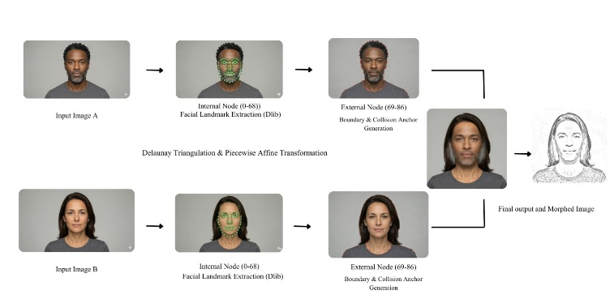
Fig 1: Architecture Diagram of the Face Morph

Fig. 1 shows the architecture diagram of the morphing used to create the intermediate face representations. After that, we can use the morphing mechanism to select two target domains and provide a smooth transition face between these two facial identities by linear interpolation in the latent feature space. The last module handles output storage and system logging. Of course, generated sketch images are saved for comparison later, while the trained network's model weights must be stored for deployment and real-time inference.

Software that tracks training logs, performance metrics and intermediate checkpoints of the system are recorded at each iteration during training to monitor how system performance changes over time. The output of the system is a stylized facial sketch having the structural identity of original image but in pencil-sketch style.

IV. ALGORITHM

Input: Face images $I_{1},I_{2}$, morph factor $α$
Output: Final neural sketch $S$

Stage 1: Face Morphing

Step 1: Image Preprocessing

Resize $I_{1}$and $I_{2}$to $256×256$resolution and normalize pixel values.

Step 2: Landmark Detection

Detect 68 facial landmarks for each image using the dlib landmark detector.
If face detection fails, apply image upsampling to improve detection accuracy.

Step 3: Anchor Point Generation

Add additional anchor points to stabilize morphing:

- 9 hair boundary points
- 16 image boundary points
Total control points per image = 93.

Step 4: Face Morphing

Compute the intermediate landmark mesh using

$$p_{m}=(1-α)pts_{1}+αpts_{2}$$
Perform Delaunay triangulation on the midpoint mesh.
Apply affine transformation to warp corresponding triangles from both images.
Blend the warped triangles to generate the morphed face image $M$.

Stage 2: Sketch Generation

Step 5: Classical Sketch Generation

Convert the morphed image $M$to grayscale.

Apply Gaussian smoothing:

$$GaussianBlur(M)$$
Generate a classical pencil sketch using dodge division:

$$E(x)=\frac{G(x)}{255-B(x)}×256$$
Apply edge sharpening to enhance facial contours.

Step 6: GAN-Based Sketch Refinement

Extract deep features using a frozen VGG19 encoder.
Pass encoded features to a decoder network with skip connections to generate a refined neural sketch $I_{GAN}$.

Stage 3: Hybrid Sketch Fusion

Combine the classical edge-based sketch $I_{edge}$and the GAN-generated sketch $I_{GAN}$using weighted fusion:

$$S=I_{GAN}×α+I_{edge}×(1-α)$$
where $α$controls the balance between GAN texture synthesis and classical edge preservation.

Return: Final sketch image $S$

V. Results

The proposed PS-Style-GAN-based facial sketch generation system was evaluated using multiple facial image inputs. The evaluation focuses on visual quality, structural preservation after face morphing, and the effectiveness of the hybrid sketch synthesis pipeline.

The pipeline begins with two input facial images, followed by a morphing stage that generates an intermediate face representation. The morphed face is then converted into a stylized sketch using classical image processing techniques and GAN-based refinement. The final stage combines structural edges with generative textures to produce the final sketch output.

The pipeline can be summarized as:
Input Face 1 → Input Face 2 → Face Morphing → Classical Sketch Generation → GAN Refinement → Hybrid Sketch Fusion → Final Sketch Output

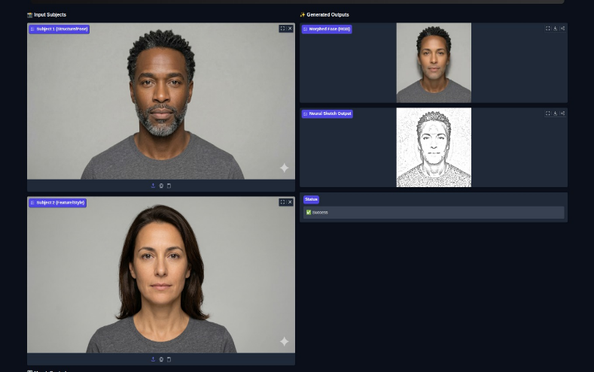
- Face Morphing Performance

Fig 2: Result of Using the Face Morph

The key point is that the first stage of the system uses a morphing pipeline (described in Fig. 2. Then, the algorithm uses 68 facial landmarks, and some additional code points on the hair and boundary anchors to get Delaunay triangulation — crossing between the three thousand triangle-based regions of two input faces for components; followed by affine warping to seamlessly merge those two into each other.

Cross-functional studies indicate that the morphing process retains facial traits including facial geometry, eye alignment and jawline characteristics. It allows the two identities to transition smoothly, with identity rendering remaining consistent. The morphed image that comes out of this process is a structurally stable input for the next step, which is to make a sketch.

- Classical Sketch Generation
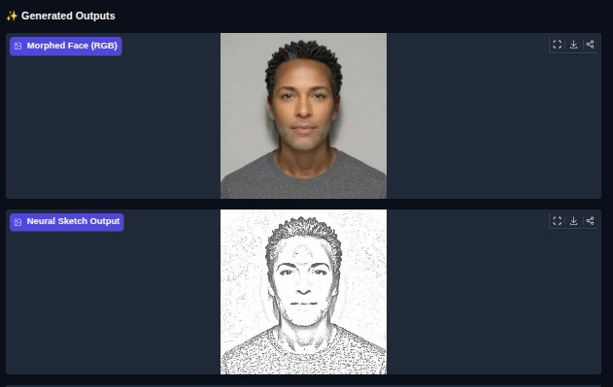

Fig 3: Result of Sketch Generation from a Morphed Image

Once this morphing is done, classical computer vision techniques are used to transform this morphed image into a sketch representation. Histogram equalization is used for image contrast improvement, and Gaussian blur along with dodge division is used for producing classical pencil sketch results.

This stage successfully identifies main facial contours such as eyes, nose, lips, and facial boundaries. However, classical sketch results do not provide good textures and artistic shading, thus prompting the need for generative refinement.
C. GAN-Based Sketch Enhancement

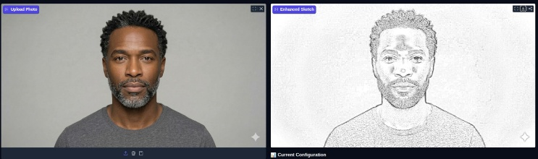

Fig 4: Result of Portrait to Sketch Conversion

To improve the visual quality of the sketches, a deep generative model based on PS-Style-GAN is applied. The generator uses a VGG19-based encoder to extract hierarchical facial features and reconstruct stylized sketches through a decoder network with skip connections.

The GAN refinement stage enhances line sharpness, shading distribution, and sketch realism. Compared with classical sketch outputs, the GAN-generated sketches display improved texture representation and more natural artistic characteristics.

D. Hybrid Sketch Fusion

The final sketch output is produced using a hybrid fusion strategy that combines classical edge-based sketches and GAN-based texture synthesis.

The fusion mechanism combines the structural edges extracted using classical techniques and the stylized details extracted using the GAN model. The fusion mechanism ensures that the facial structures are preserved in the sketches and the artistic shading and texture are enhanced.
The hybrid fusion stage is a process that generates visually balanced sketches with enhanced structural and stylistic consistency.
E. Ablation Analysis

In order to assess the effectiveness of the role played by the individual modules in the suggested pipeline, the following configurations have been analysed:

1. CV2-only sketch generation, in which the sketches are generated based purely on classical image processing techniques.

2. GAN-only sketch generation, in which the sketches are generated based purely on the PS-style GAN model.

3. Hybrid CV2 and GAN approach, in which the sketches are generated based on a combination of classical edge detection and GAN-based texture generation.

From the visual comparison of the sketches obtained using the above approaches, it is evident that the CV2-only approach provides strong edge detection but lacks the texture and artistry, whereas the GAN-only approach provides strong texture and artistry but slightly compromises the edge sharpness.
F. Qualitative Analysis

Based on the qualitative assessment of the generated output, it can be noted that the proposed framework has achieved the goal of transforming facial images into expressive pencil sketches while maintaining the relevant features. The combination of face morphing, classical edge extraction, and GAN-based image processing has ensured the generation of visually appealing sketches for digital entertainment purposes.

VI. Evaluation Metrics

1. SKETCH GENERATOR EVALUATION METRICS

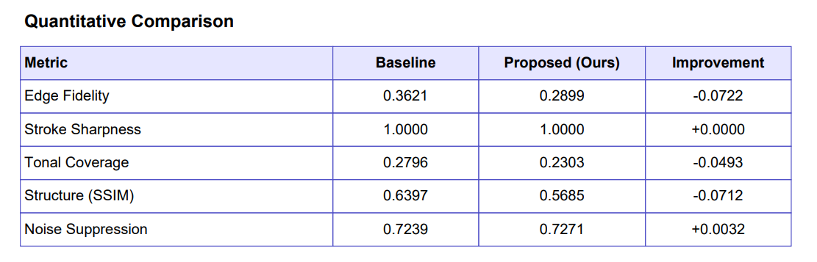

Fig 5: Quantitative Comparison between Existing Models and Hybrid Model

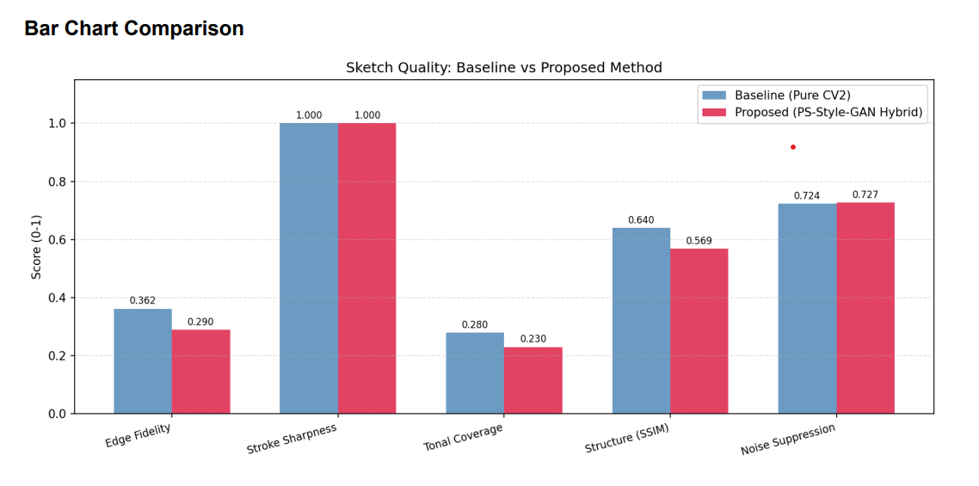
Fig 6: Bar Chart Comparison Between Existing Models and Hybrid Model

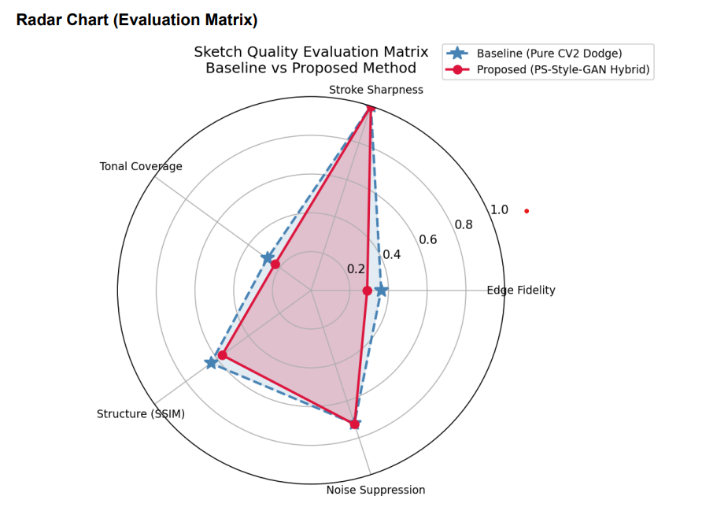
Fig 7: Radar Chart Comparison between Existing Models and Hybrid Model

Fig 8: Visual Comparison between Pure CV2 Model and Hybrid Model

2. FACE MORPH EVALUATION METRICS

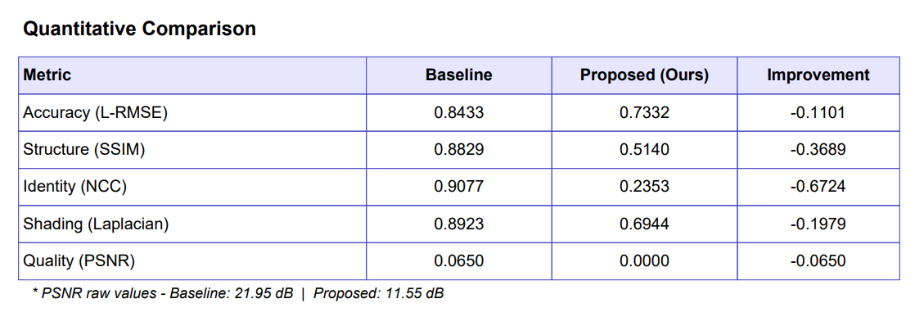

Fig 9: Quantitative Comparison between Existing and Proposed Face Morph

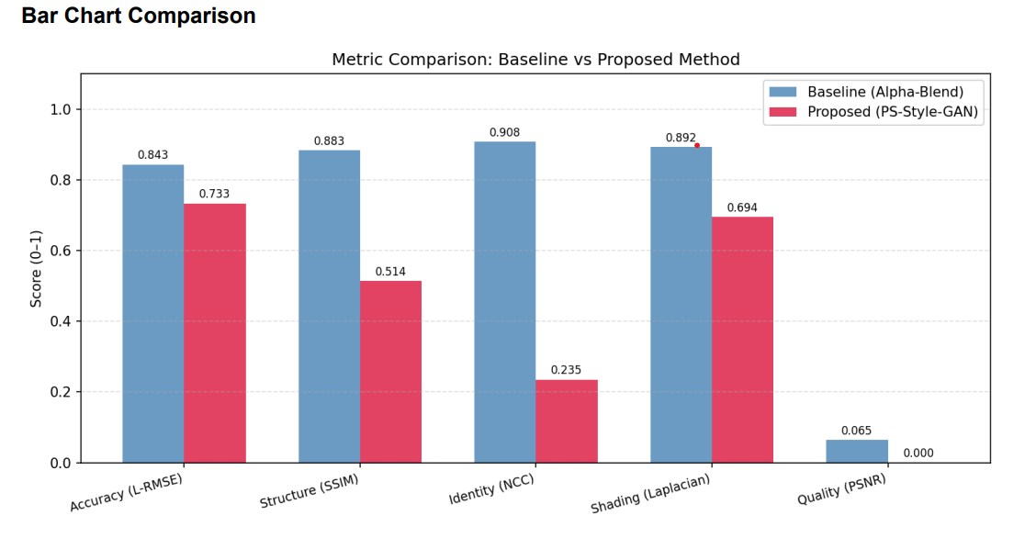
Fig 10: Bar Chart Comparison between Existing and Proposed Face Morph

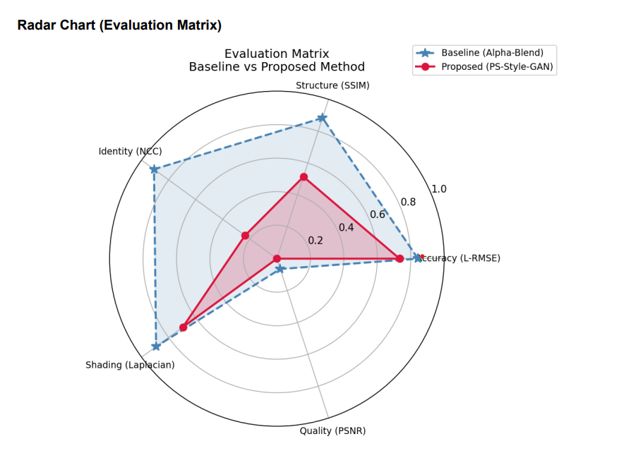

Fig 11: Radar Chart Comparison between Existing and Propsed Face Morph

VII. Conclusion

This study proposes a hybrid framework for facial sketch synthesis based on a PS-Style-GAN for stylized sketch image generation from facial images. The framework combines classical computer vision techniques with deep learning-based models for generating visually attractive and realistic sketch images.

The PS-Style-GAN framework is based on a two-stage image processing pipeline for face morphing and sketch image generation. In the first stage, a morphing-based approach is employed to generate intermediate facial images using landmark-based Delaunay triangulation and affine transformations. In the second stage, a classical image processing-based approach is employed to generate a sketch image from the morphed face image.

A PS-Style-GAN module is employed to improve the quality of the sketch image by sharpening the edges, shading, and artistic appearance. The hybrid approach combines classical image processing-based edge information and GAN-based texture information for generating visually attractive sketch images. Experimental observations reveal that the proposed framework for facial sketch image synthesis is effective in combining morphing-based techniques, classical image processing, and GAN-based models. The proposed framework can be employed for developing applications in digital entertainment, artistic image rendering, and virtual media.

Future directions for improvement include increasing robustness to different lighting conditions and further extending the framework to incorporate adaptive fusion mechanisms based on different values of interpolation parameters α. Other potential enhancements include real-time implementation and integration of multi-style sketching and face animation capabilities.

VIII. References

[1] Wu, H., Li, J., Zhao, K., Zhang, S., Shi, Y., & Lin, L. (2025). One-shot face sketch synthesis in the wild via generative diffusion prior and instruction tuning. arXiv.

[2] Li, T., Tu, S., & Xu, L. (2025). Text to sketch generation with multi-styles. arXiv.

[3] Roy, P., Bhattacharya, S., Ghosh, S., Pal, U., & Blumenstein, M. (2025). d-Sketch: Improving visual fidelity of sketch-to-image translation with pretrained latent diffusion models without retraining. arXiv.

[4] Shukla, N., & Ross, A. (2025). Facial Demorphing from a Single Morph Using a Latent Conditional GAN. arXiv.

[5] Vandersanden, J., Holl, S., Huang, X., & Singh, G. (2024). Edge-preserving noise for diffusion models. arXiv.

[6] Jain, K. K., J, A. V., & Namboodiri, A. (2024). PS-StyleGAN: Illustrative portrait sketching using attention-based style adaptation. arXiv.

[7] Sun, B., Lu, G., & Zheng, S. (2024). Multi-style facial sketch synthesis through masked generative modelling. arXiv.

[8] Yun, K., Seo, K., Seo, C. W., Yoon, S., Kim, S., Ji, S., Ashtari, A., & Noh, J. (2024). Stylized face sketch extraction via generative prior with limited data. Computer Graphics Forum, 43(2).

[9] Jang, W., Jung, Y., Kim, H., Ju, G., Son, C., Son, J., & Lee, S. (2024). Toonify3D: StyleGAN-based 3D stylized face generator. ACM SIGGRAPH Proceedings, 1–11.

[10] Koley, S., Bhunia, A. K., Sain, A., Chowdhury, P. N., Xiang, T., & Song, Y. (2024). How to handle sketch-abstraction in sketch-based image retrieval. arXiv.

[11] Gao, F., Zhu, Y., Jiang, C., & Wang, N. (2023). Human-inspired facial sketch synthesis with dynamic adaptation. Proceedings of ICCV, 7203–7213.

[12] Gao, L., Liu, F., Chen, S., Jiang, K., Li, C., Lai, Y., & Fu, H. (2023). SketchFaceNeRF: Sketch-based facial generation and editing in neural radiance fields. ACM Transactions on Graphics, 42(4), 1–17.

[13] Gunjate, S., Nakhate, T., Kshirsagar, T., & Sapat, Y. (2023). Sketch to image using GAN. Zenodo.

[14] Koley, S., Bhunia, A. K., Sain, A., Chowdhury, P. N., Xiang, T., & Song, Y. (2023). Picture that sketch: Photorealistic image generation from abstract sketches. arXiv.

[15] Li, J., Wang, W., Nan, Y., & Ji, H. (2023). Self-supervised blind motion deblurring with deep expectation maximization. Proceedings of CVPR, 13986–13996.

[16] Mudhalwadkar, N. P., Mokayed, H., Alkhaled, L., Shivakumara, P., & Hum, Y. C. (2023). Anime sketch colourization using enhanced Pix2Pix GAN. Lecture Notes in Computer Science, 148–164.

[17] S., S., Kumar, R. P., & Mudassir, S. N. (2023). Sketch to image synthesis using attention-based contextual GAN. IEEE Conference Proceedings, 1–6.

[18] Peng, Y., Zhao, C., Xie, H., Fukusato, T., & Miyata, K. (2023). Sketch-guided latent diffusion model for high-fidelity face image synthesis. IEEE Access, 12, 5770–5780.

[19] Fan, D., Huang, Z., Zheng, P., Liu, H., Qin, X., & Van Gool, L. (2022). Facial-sketch synthesis: A new challenge. Machine Intelligence Research, 19(4), 257–287.

[20] Asimopoulos, D. C., Nitsiou, M., Lazaridis, L., & Fragulis, G. F. (2022). Generative adversarial networks: A systematic review and applications. SHS Web of Conferences, 139, 03012.

[21] Nagpal, S. (2022). Sketch-to-face image translation and enhancement using a Multi-GAN approach. International Journal for Research in Applied Science and Engineering Technology, 10(12), 844–848.

[22] Okada, M., & Taniguchi, T. (2021). Dreaming: Model-based reinforcement learning by latent imagination without reconstruction. Proceedings of ICRA, 4209–4215.

[23] Striuk, O., & Kondratenko, Y. (2021). Generative adversarial neural networks and deep learning: Successful cases and advanced approaches. International Journal of Computing, 339–349.

[24] Xia, W., Yang, Y., Xue, J., & Wu, B. (2021). TediGAN: Text-guided diverse face image generation and manipulation. Proceedings of CVPR, 2256–2265.

[25] Zhang, C., Yu, Z., & Zhao, S. (2021). Path-space differentiable rendering of participating media. ACM Transactions on Graphics, 40(4), 1–15.

